***Adding and Removing Elements with jQuery***

Prepend:

Add element in selected item just after opening tag.

Append:

Add element in selected item just before closing tag.

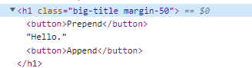

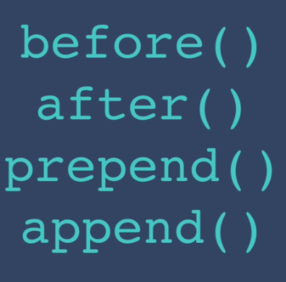

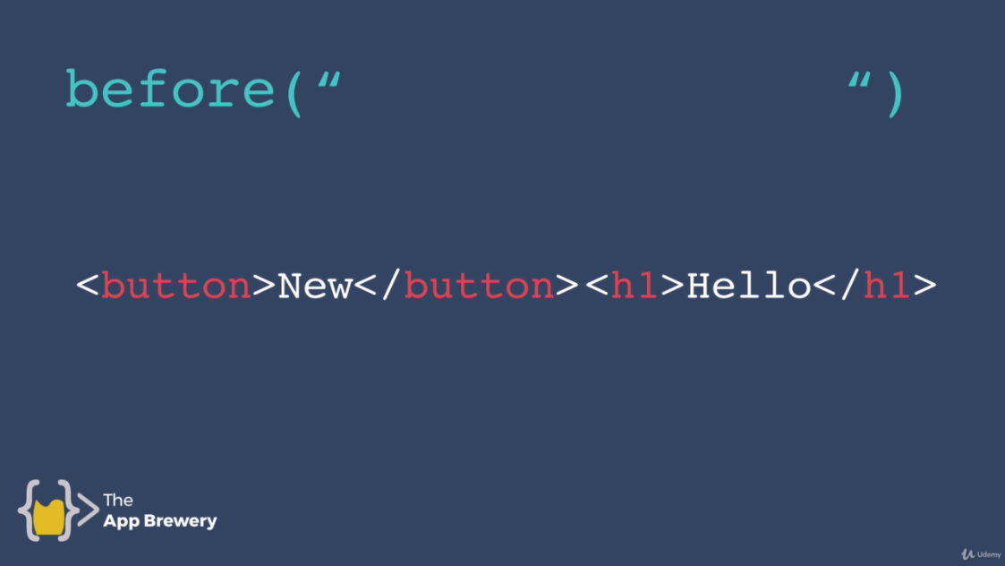

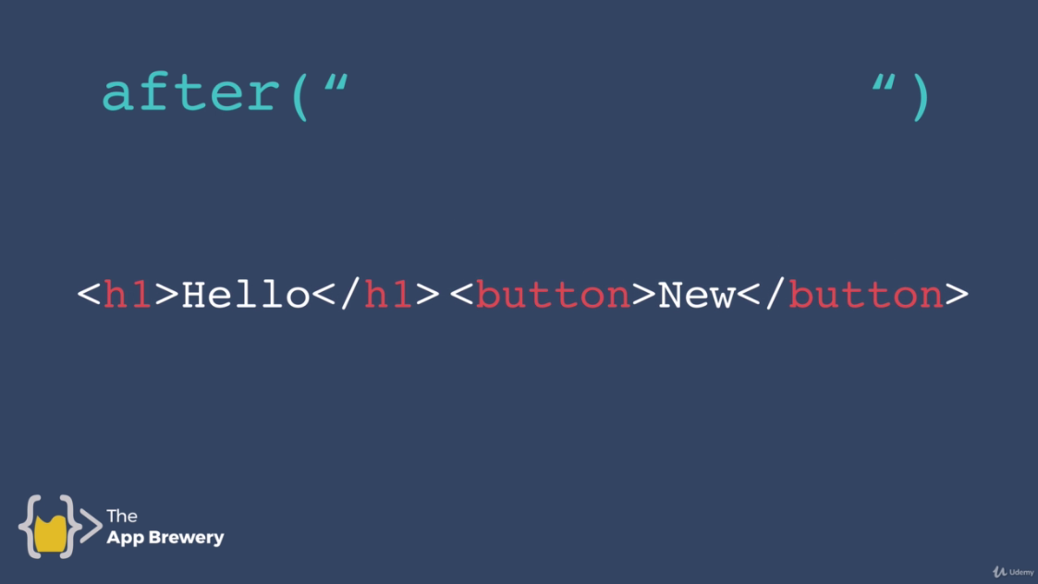

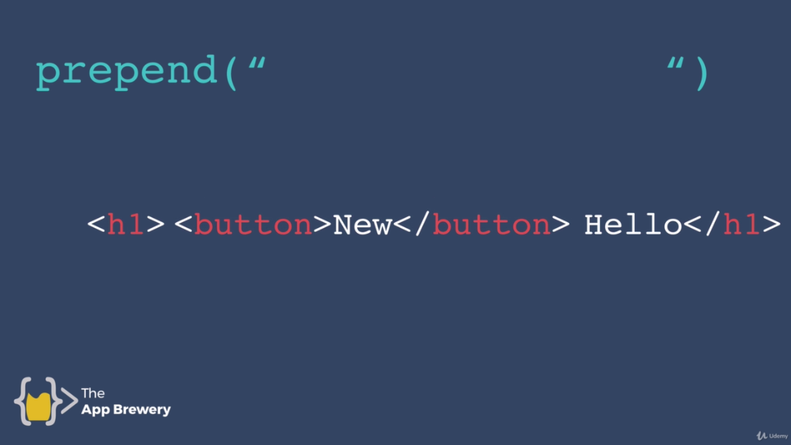

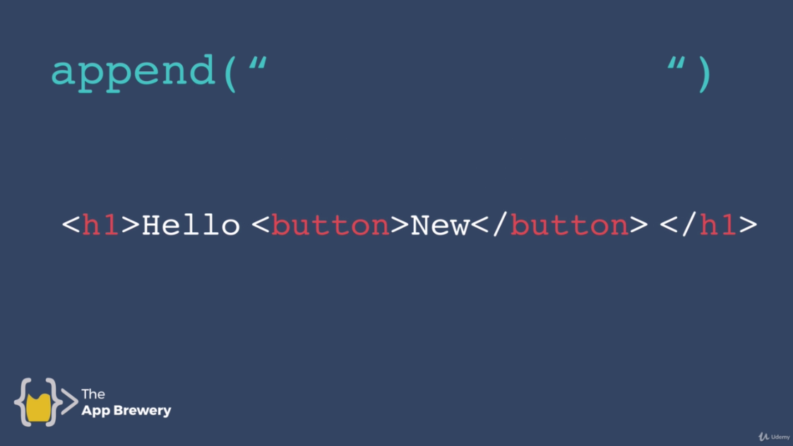

**Code:**

**Index5.html:**

<!DOCTYPE html>

<html lang="en" dir="ltr">

<head>

<meta charset="utf-8">

<title>jQuery</title>

<link rel="stylesheet" href="styles5.css">

</head>

<body>

<h1 class="big-title margin-50">Hello.</h1>

<img src="drum.png" alt="">

<a href="http://www.google.com">Search</a>

<!--We want to add a and img attributes using js and jQuery-->

<button>Click Me</button>

<button>Click Me</button>

<button>Click Me</button>

<button>Click Me</button>

<button>Click Me</button>

<input type="text" name="" value="">

<script src="https://ajax.googleapis.com/ajax/libs/jquery/3.6.0/jquery.min.js"></script> <!--Paste it above below tag-->

<script src="index5.js" charset="utf-8"></script>

</body>

</html>

**Index5.js:**

//Let's add button using before element

//Syntax

//$<Element>.before<html Element that we want to add>

$("h1").before("<button>New</button>");

//After functions

$("h1").after("<button>After</button>");

//prepend

$("h1").prepend("<button>Prepend</button>");

//Append

$("h1").append("<button>Append</button>");

//Let's remove all of the noOfButtons

//$("button").remove();

**Styles5.css:**

.big-title{

font-size: 10rem;

font-family: cursive;

color: yellow;

}

.margin-50{

margin: 50px;

}